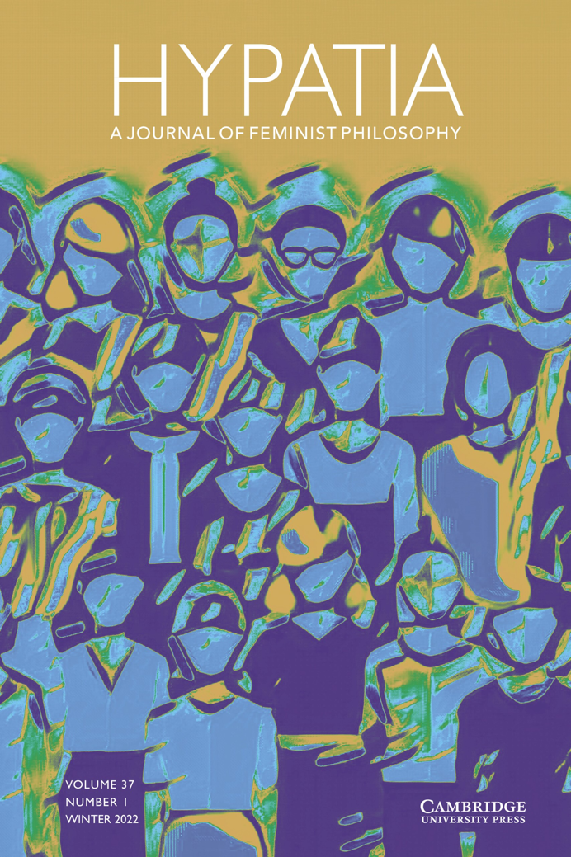
ANNUAL REPORT FOR 2022

Final – June 2022

Hypatia Editors

Bonnie Mann (January 2019 –)

Erin McKenna (January 2019 –)

Camisha Russell (January 2019 –)
Rocío Zambrana (September 2018 –)

Hypatia Reviews Online Editors
Erin McKenna (January 2019 –)
Clara Fischer (January 2020 –;
on leave February 2022 – March 2023)
Maggie Newton (March 2022 –May, 2023)

Hypatia Managing Editors
Sarah LaChance Adams (January 2019 –)
Caroline Lundquist (March 2020 –)

Hypatia Editorial Assistant
Brooke Burns (March 2020 – March 2022)
Annie Ring (March 2022 –)

HRO Managing Editor
Maggie Newton (December 2021 – March 2022)

Kenny Knowlton (March 2022 –March 2023)

Zeinab Nobowati (March 2023-)

OVERVIEW

This 2022 annual report was drafted after the full 2022 report from Cambridge University Press was delivered to the Editors (April). It was presented to all interested parties within Hypatia’s tripartite governance structure during an Annual General Meeting (FILL IN DATE, 2023). It covers the period from January 1 through December 31, 2022 (with some additional insights from the first months of 2023).

The report has been drafted by all members of the Editorial Team, and the Managing Editors. Since fall of 2022, the position of Coordinating Editor has rotated each term, since all members of the Editorial Team had previously completed a full year-long term as Coordinating Editor. The position is currently held by Bonnie Mann, who coordinated efforts to complete this report. A number of staffing changes occurred during 2022, please see dates listed above.

Accomplishments, 2022 (see below for details)
- Search for new Hypatia Editorial Team.
- Feminism in Translation feature continued with full volume of translated articles.
- Return of published interviews to Hypatia.
- The creation of the Hypatia archive at the University of Oregon Knight Library.
- Planning for Hypatia’s 40th Anniversary conference at the University of Oregon (Fall 2023)
- Launch of Keywords Project
- Revision of ME Manual

BOARDS AND GOVERNANCE

The governance structure for Hypatia has been working well, with communication and collaboration across boards as needed.

Non-Profit Board

Members of the Non-Profit Board in 2022 included: Linda Martín Alcoff (president), Ladelle McWhorter (Secretary), Nancy Tuana (Treasurer), Kris Sealey, Jacqueline Scott, María del Rosario Acosta (Associate Editors’ representative), Rocío Zambrana (Co-Editors’ representative), and Ann Garry (ex-officio). During the Fall 2022 meeting, the NPB voted on new President and Treasurer. Falguni Sheth will be transitioning into the role of President of the NPB during fall 2023. Laurie Shrage will be transitioning into the role of Treasurer of the NPB during fall 2023 as well.

NPB President Linda Alcoff reports that throughout the year, the NPB made an effort to address the issue concerning the establishment of the Hypatia archives at UO. Archive materials continue to be held by Southern Illinois University, but are rarely used and poorly catalogued there. The NPB used both back channels and direct appeal to SIU. The NPB helped with the search for the new editorial team. The NPB of course maintained a careful eye on the budget and managed to provide significant funds for the Fall Hypatia conference in Oregon.

Editorial Team

The four Co-Editors of Hypatia remain Bonnie Mann, Erin McKenna, Camisha Russell, and Rocío Zambrana. The coordinating Co-Editors for 2022 were Rocío Zambrana (whose one-year term ended in September 2022) and Erin McKenna (fall 2022). Camisha Russell took on the Coordinating Editor position in winter of 2023, and Bonnie Mann is in the role currently (spring 2023). Rocío Zambrana will resume this role in summer and fall of 2023 while other co-editors take on a larger role in the organizing of the 40th Anniversary conference. The official term of this Editorial Team ends December 31, 2023. The new Editorial Team (TBD) will “shadow” the current team during Fall 2023 for a smooth transition.

The ET has continued to work with a lack of adequate institutional support. We hope that the new team will have better luck negotiating more robust institutional support for their work.

Board of Associate Editors

The Board is composed of Robin Zheng (Chair), María del Rosario Acosta-López (Chair of Search Committee), Saray Ayala-Lopez, Talia Mae Bettcher, Ann E. Cudd, Vrinda Dalmiya, Verónica Gago, Dilek Huseyinzadegan, Qrescent Mali Mason, Krushil Watene, and Yolonda Y. Wilson. The Board headed the search for the new Editorial Team.

[I asked María and Ann whether Robin was chair of AEs, since I heard she had to step down. No answer. Annie is checking as well. ]

Outreach and Ethics Committee

Committee members are Camisha Russell (Chair), Kris Sealey, and Yolanda Wilson. The Committee is committed to generating standards for the journal’s publication ethics. They did not receive requests for review or outreach during 2022.

Facilitation and Communication Committee

Committee members are Erin McKenna, Jackie Scott, Talia Bettcher. This committee has not yet met in 2022, due to a lack of conflicts to mediate.

International Advisory Board

The Board is composed of the following members: Marzena Adamiak (Poland), Anatasia Christou (UK), Annabelle Dufourcq (France/Netherlands), Shannon Hoff (Canada), Alexandra Kokoli (UK), Rozena Maart (South Africa), Rosaura Martínez Ruíz (Mexico), Kelly McWilliam (Australia), Laura Quintana (Porras, Colombia), Stephanie Rivera Berruz (USA/Puerto Rico), Senka Anastasova (North Macedonia), Falguni Sheth (India/USA), Beata Stawarska (Poland/USA), Marcia Tiburi (Brazil/France), Çiğdem Yazici (Turkey).

In 2022, there was no significant interaction with the International Advisory Board. It would be good for the new editorial team to consider whether to maintain this board, and to evaluate how the IAB can play a more significant role in extending Hypatia’s reach internationally.

JOURNAL CONTENT

Volume 37 (2022)

37.1  Winter | Open Issue | 8 articles | 1 editorial note (interviews); 1 interview; 3 musings; 2 invited review essays
37.2  Spring | Open Issue | 11 articles | 1 introduction (Feminism in Translation); 1 translation
37.3  Summer | Decolonial Feminism in Latin Amefrica: An Essential Anthology (Special Issue) |  | 1 editorial note; 1 introduction; 8 translations; 1 book review
37.4  Fall | Open Issue | 10 articles | 1 musing
Total |  | 29 articles | 2 editorial notes; 2 introductions; 1 interview; 9 translations; 2 review essays; 4 musings; 1 book review

Volume 38 (2023)

38.1  Winter | Open Issue  Cluster: Women’s Agency Under Misogyny | 10 articles | 1 ME cluster introduction, 1 interview
38.2  Spring | Open Issue  Cluster: Obstetric Violence | 12 articles | 1 musing; 1 cluster introduction
38.3  Summer | Open Issue | 11 articles | 1 musing; 1 review essay
38.4  Fall | Special Issue: Intersectional Epistemologies | 11 articles (tentative) | 1 musing; 1 editors’ introduction
Total |  | 44 articles | 2 cluster introductions; 1 interview; 3 musings; 1 review essay

We are now filling volume 39 (2024).

Slated for Volume 39:
39.1:
9 articles
1 musing
39.2:
9 Articles
2 musings
39.3:
9 articles
1 musing

Our return to pre-2017 submission rates remains solid; our production schedule has remained on time (see below and Cambridge University Press annual report for more detail). At this time, the journal has a wait time between final acceptance and publication (posted online on First View) of around 18 months. While these are signs of health, they also represent a backlog that requires attention. The Team has an ongoing conversation about how to address the acceptance rate in light of this backlog.

Special Issues

The Editorial Team is committed to publishing one special issue per volume.

Issue | Title | Guest Editor(s)
Published
37.3 | Decolonial Feminism in Latin Amefrica: An Essential Anthology (Feminism in Translation) | Yuderkys Espinosa Miñoso
Scheduled
38.4 | Intersectional Epistemologies: The Ethics and Politics of Epistemic Practice | Gaile Pohlhaus, Jr. Jeanine Weekes Schroer

Clusters

As the tables above show, during 2022, Hypatia published two clusters:

As noted above, we have possible found clusters on Care/Care Ethics and on Colonialism and a submitted cluster on Philosophy of Birth slated for volume 38. We continue to receive and solicit proposed clusters and would welcome help from members of the Hypatia community in soliciting further timely and innovative clusters.

Feminism in Translation
The Feminism in Translation feature was developed further in 2022, its second year. Launched in 2021, the feature was intended as one small step to intervene in a situation of global language bias, where works written in English that gain some traction with a significant audience are often translated into other languages, while it is much less common, with a few exceptions, for translations to go the other way.

After working with CUP in 2021 to create the necessary workflows in ScholarOne, and developing a review process for translations, we published one significant translation in 2021. Another stand-alone article translation, “Ecofeminist Degrowth for Sustaining Buen Convivir” by Amaia Pérez Orozco, translated by Liz Mason-Deese appeared in 37.2. The entirety of Volume 37.3 is devoted to translations: Decolonial Feminism in Latin Amefrica: An Essential Anthology, a special issue edited by Yuderkys Espinosa Miñoso. The special issue makes available to English language readers key essays in in contemporary feminist decolonial thought in “Latin Amefrica,” bringing this important term which emphasizes the African and Amerindian dimensions of life and thought in what most white feminists refer to as “Latin America,” into the mainstream of feminist philosophy in the English language. It contains essays by Ochy Curiel, Betty Ruth Lozano, Carmen Cariño, Breny Mendoza, Celenis Rodriguez, Claudia Pons Cardozo and Yuderkys Espinosa. Translations by Ruth Pión, Lia Espinosa, Ale Montelongo, and Daniela Ortiz, translators from activist spaces linked to the work, sought to shift the resources slated for this issue to the communities most relevant to the work.

Interviews

The Editorial Team made the decision to resume interviews of feminist scholars in 2021, after not publishing interviews since 2008. We agreed that interviews would be reviewed by the Editorial Team, but not subjected to anonymous review. The first interview appeared in Volume 37.1, the second in Volume 38.1. From Camisha Russell’s editorial note about this decision:

We the co-editors are pleased to announce that the journal will return to publishing interviews with feminist scholars. Though establishing a fair and adequate review process for interviews can be challenging, we feel that not publishing interviews in one of the small number of journals dedicated to feminist philosophy may serve as a barrier to continuing and nuanced engagement with the work of significant feminist thinkers. In the broader field, published interviews with canonical, nonfeminist philosophers often become important and highly cited parts of secondary work on these thinkers. As a major source of feminist philosophical scholarship, Hypatia can contribute to deeper scholarly engagement with influential feminist philosophers through this form.

We hope that, in the spirit of our new Feminism in Translation initiative, the interview feature will be used to highlight or introduce the work of feminist scholars working primarily in languages other than English or coming from traditions of feminist thought outside the mainstream of Hypatia articles. We seek not just to increase the bandwidth of established feminist voices, but to introduce and amplify less familiar voices at the margins of our current disciplinary boundaries. For this, especially, we ask your help.

In 37.1 Hypatia published “From Social Construction to Social Critique: An Interview with Sally Haslanger” by Jeremiah Joven B. Joaquin, Hazel T. Biana (37.1, winter 2022), and in 38.1 “Simone de Beauvoir: Analogy, Intersectionality, and Expanding Philosophy,: an Interview with Kathryn Sophia Belle, conducted by Edward O’Byrne (38.1, winter, 2023). We also rejected submitted interviews, even with very famous scholars, when we did not feel they expanded the discussion of that scholar’s work significantly. If the new editorial team continues to publish interviews, it will be important to work to fulfill the aspiration to diversify this feature of the journal.

Hypatia Reviews Online

Hypatia book reviews are now published (online only) through the Cambridge University Press Hypatia site. All past Hypatia book reviews have migrated to that site.

In 2022, HRO published 22 book reviews and 1 review essay. We had to pause our processes while we sorted out some issues. The 2022 numbers are lower than usual due to several turn overs in the role of HRO’s ME which necessitated additional training periods, and a co-editor being on maternity leave. The anticipated rate of book review publication is 5 reviews per month. Currently, there are 19 books reviews and 2 review essays in production. Cambridge will soon take over the copyediting of book reviews and the entire process will migrate to Scholar One, simplifying the editorial process.

Year | Book Reviews Published | Review Essays Published
2019 | 50 | 4
2020 | 40 | 1
2021  2022 | 20  26 | 1  2

Curated Online Collections

Cambridge University Press encourages curated online collections on the Cambridge Core Hypatia website. This content is made open access for a period, and the collection is marketed by Cambridge and through social media and listservs. After several significant curated collections in 2020 and 2021, there were no curated collections in 2022. We encourage the new editorial team to continue to look for opportunities to offer curated collections open access to our readers.

DIVERSITY PROJECT GRANTS
Diversity Project Grants were suspended in 2022 and will be suspended in 2023. The Associate Editors have been consumed with the search for a new editorial team for Hypatia (see report on this search below), and decided that this had to be the central focus of their work.

SUBMISSIONS, DECISIONS AND OTHER DATA

Submissions

Manuscript Type | Original | Revised | Total
Article | 185 | 67 | 252
Book Review | 27 | 14 | 41
Interview | 1 | 0 | 1
Invited Review Essay | 2 | 2 | 4
Musing | 15 | 6 | 21
Translation | 2 | 7 | 10
Total | 233 | 96 | 329

This table gives the number of articles submitted from January 1, 2022 to December 31, 2022. It is divided between original submissions and revisions. The CUP numbers in the acceptance rate graph below are slightly different from these numbers we pulled from ScholarOne, but CUP considers the ScholarOne reports the more accurate number. Submissions are up just slightly from 2021.

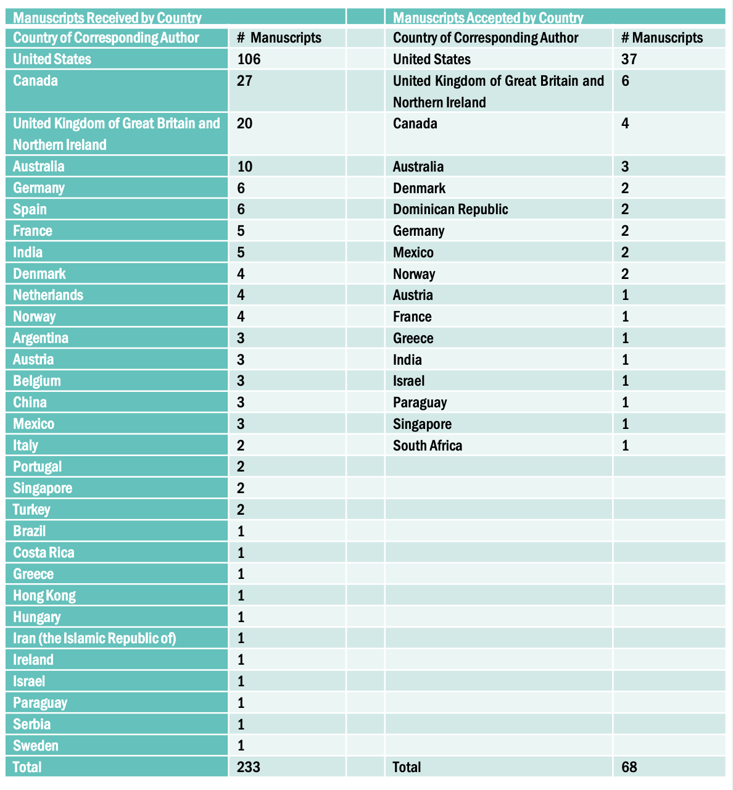
Acceptance Rates

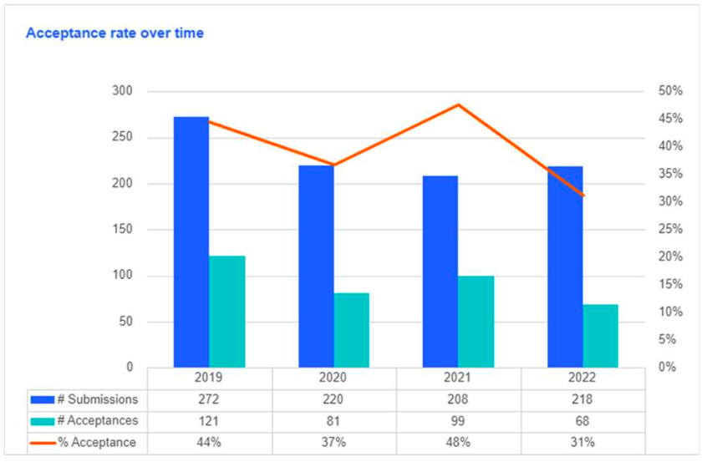

This graph provided by Cambridge University Press (CUP) suggests that the overall acceptance rate for 2022 has decreased from 2021. Last year, the Editorial Team became increasingly concerned with the current backlog of articles waiting to be published. To address this situation, we revised reviewer instructions to request substantive feedback that explains recommendations and offers constructive suggestions, yet stressing that this request for generosity in providing feedback should not be understood as a call for generosity in the recommended editorial decision. The Team also adjusted the decision chart to allow for rejection rather than continued cycles of revision where appropriate. This graph may indicate that some of our efforts have been successful, but accurate acceptance rates have been tricky given the amount of time some manuscripts spend in the system. The tables below attempt to help create a fuller picture.

Final Decisions Last 5 Years (Articles Only)

Year Submitted | 2018 | 2019 | 2020 | 2021 | 2022
Articles w/ final decision | 88 | 101 | 102 | 124 | 141
% Accept | 44% (39) | 34% (34) | 45% (46) | 37% (46) | 39% (55)
% Reject | 56% (49) | 66% (67) | 55% (56) | 63% (78) | 61% (86)

Manuscript Decisions by year submitted (last five years)

2018 2019
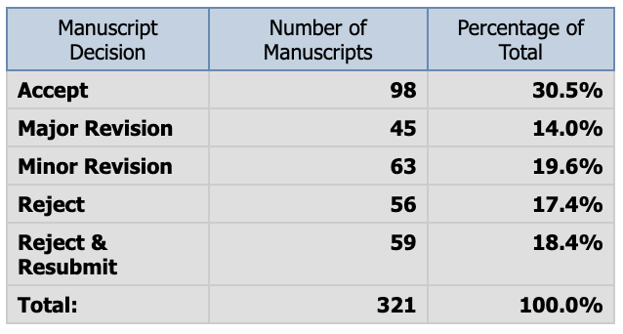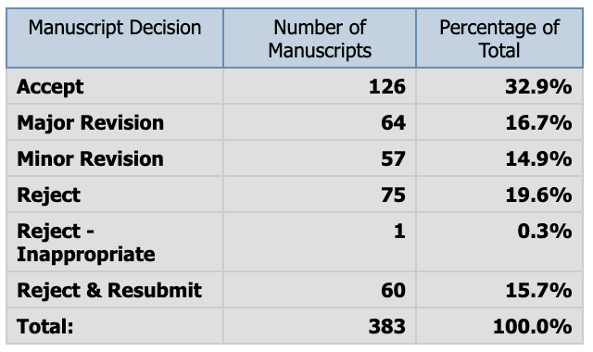
2020 2021
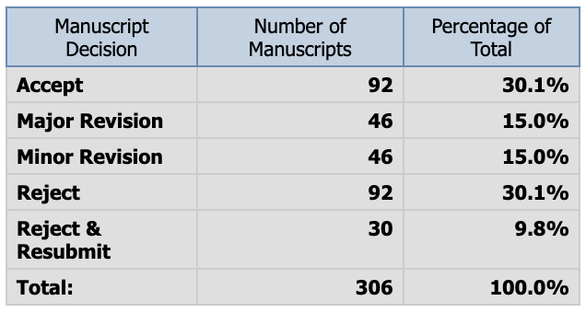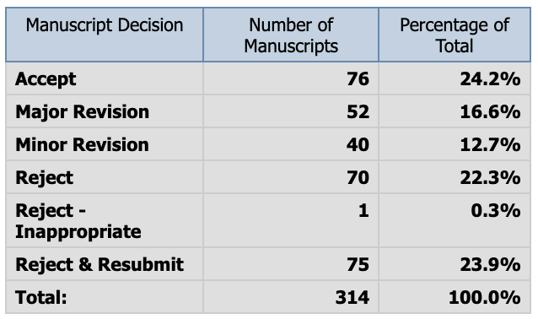
2022
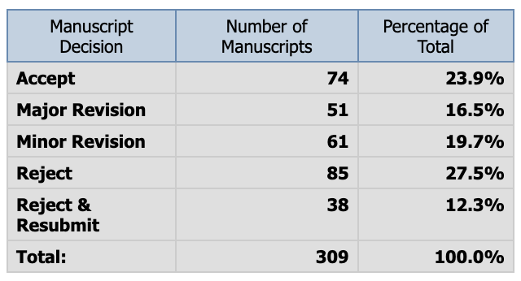

Rejection without Review (Desk Rejections)
Note: All reject-without-review decisions must be seconded by a 2nd editor.

Year | Total submissions | Desk rejections | % of submissions desk rejected
2018 | 169 | 16 | 9.4%
2019 | 188 | 19* | 10.1%*
2020 | 175 | 30 | 17.1%
2021 | 178 | 43 | 24.16%
2022 | 200 | 37 | 18.5%
*some information from this year was lost

Pages & Articles Per Year

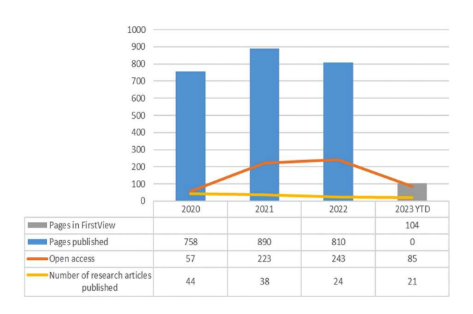
Our page budget with Cambridge University Press is currently 1200 pages per year. CUP does not see the page limit as a definite factor in content to be published. However, the Editorial Team sees labor costs as correlated to the page limit.

Turnaround Times

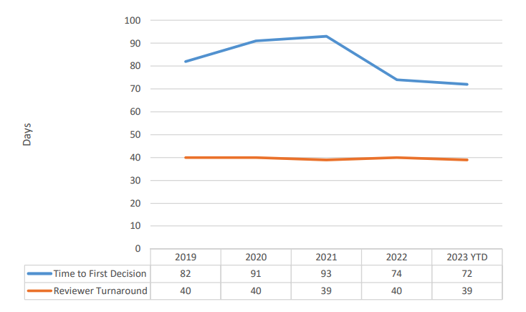

OPEN ACCESS

CUP is now assessing every journal, on an annual basis, to determine its eligibility to flip to a full open access model for its research content. This will be an important issue for the new editorial team. CUP considers a flip viable once they can be confident that the vast majority of authors are covered for open access publishing, either through CUP’s transformative agreements or Article Processing Charge (APC) funding in the field, and they are in position, through other equity initiatives and, ultimately, through waivers, to guarantee a financially sustainable publishing route for everyone else.

‘Flip’ decisions require a long lead time, as the pipeline of submitted content often means a ‘flip’ for new submissions needs to take place long before the volume year in which subscriptions are discontinued. CUP will need to make decisions about journals to flip in 2025 by October 2023. According to CUP, thanks to their transformative agreement programme, over 75% of authors publishing research content in Hypatia are able to publish open access (see below). They project that this will increase to over 90% by 2025, and look forward to discussing with Hypatia the optimal point to flip the journal’s research content to open access entirely.
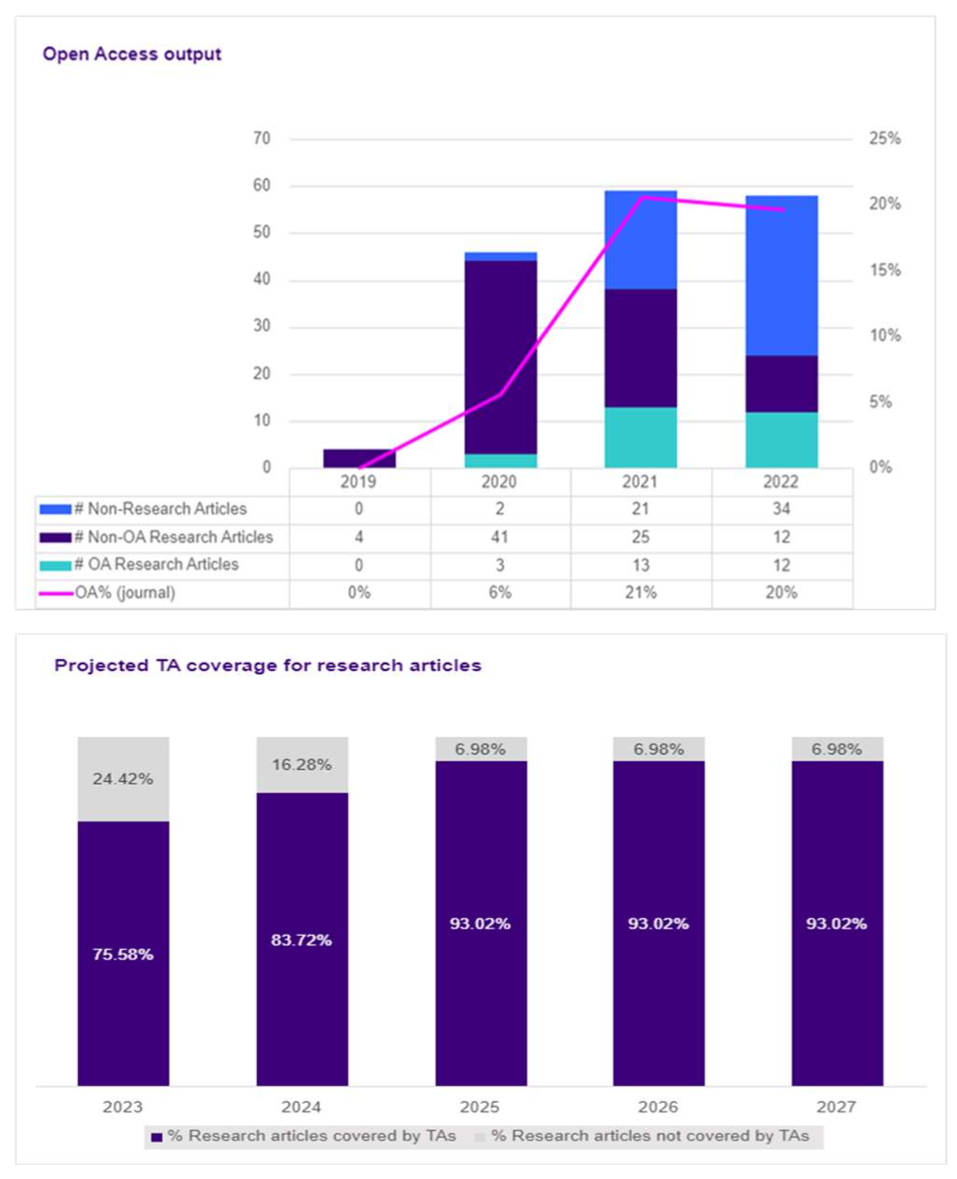

SUBSCRIPTIONS, ONLINE USAGE, IMPACT METRICS & POPULAR ARTICLES

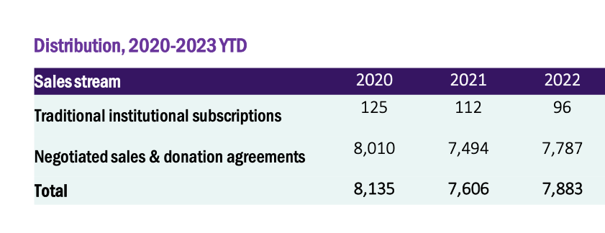
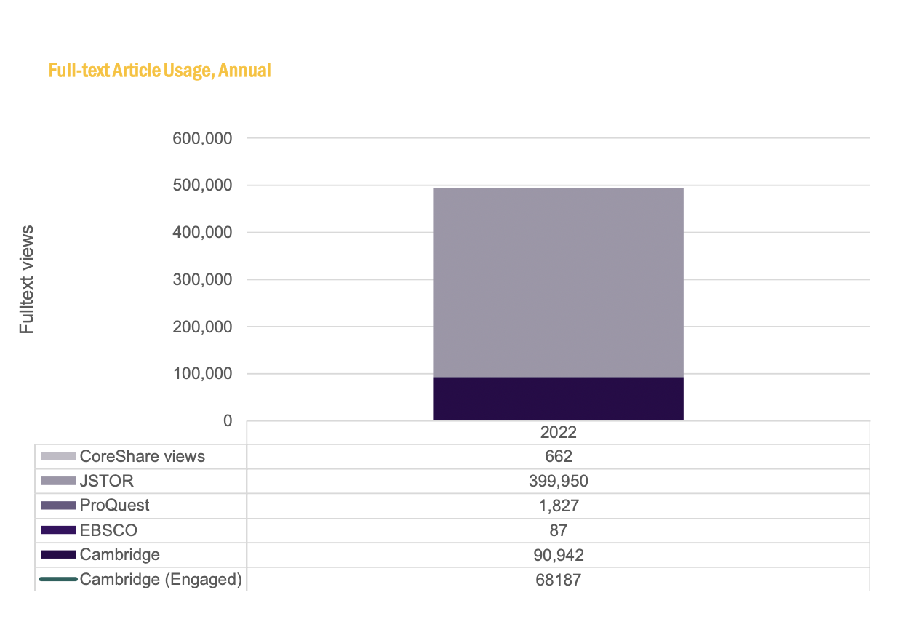
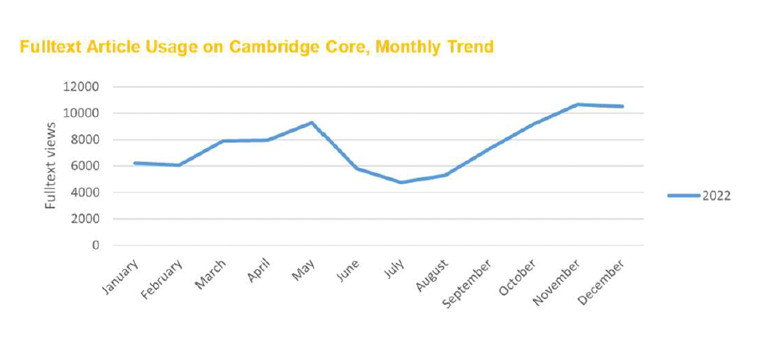

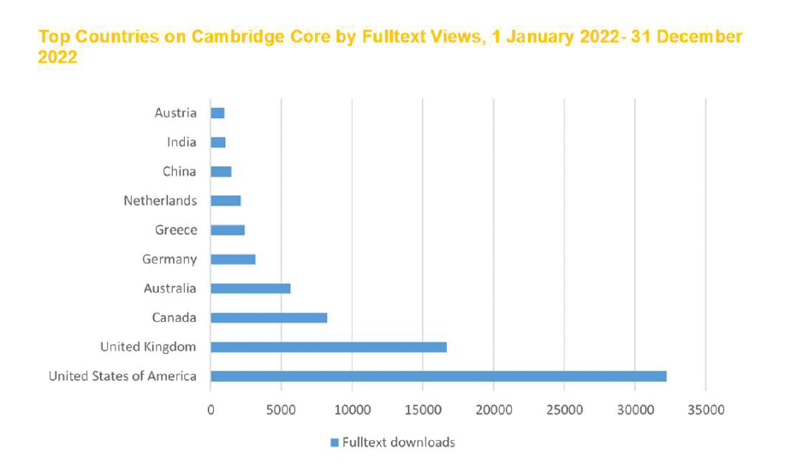

Impact Metrics

Impact Factor

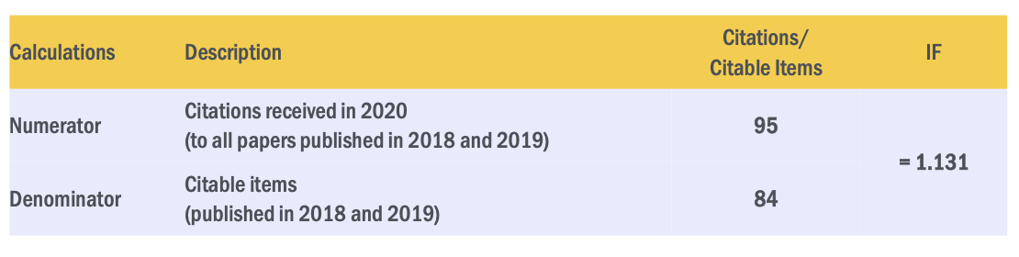
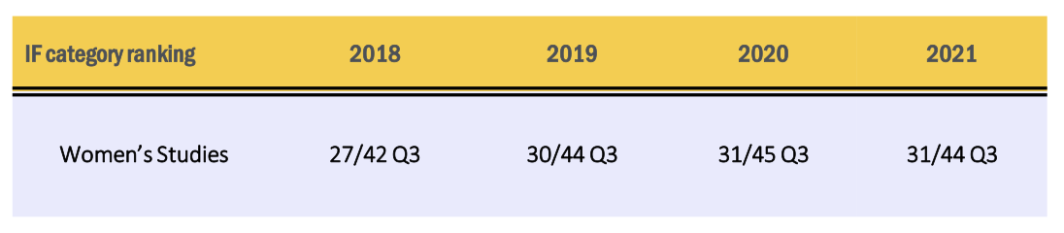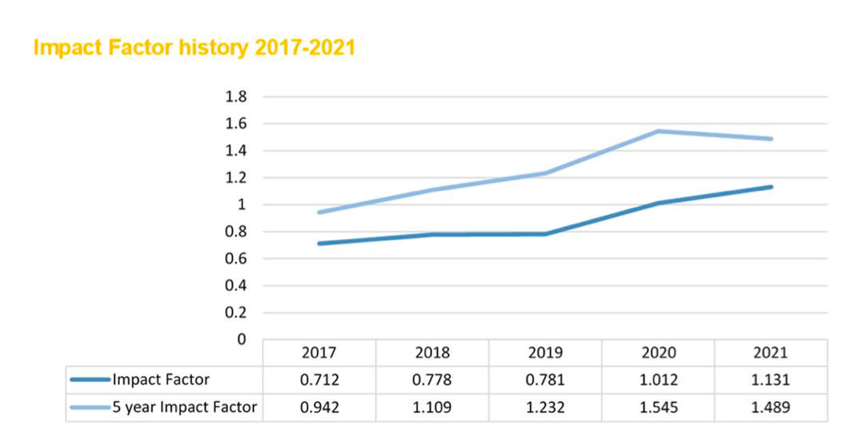
Journal Citation Indicator (JCI)
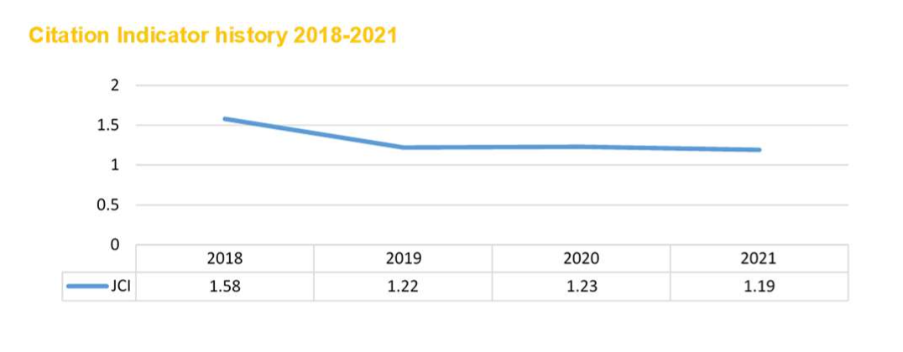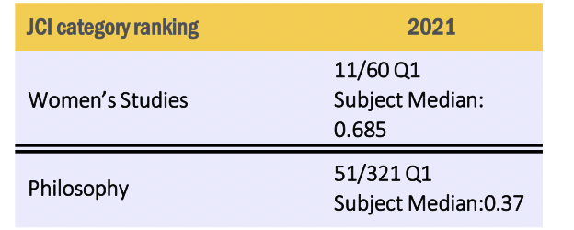

Scopus CiteScore
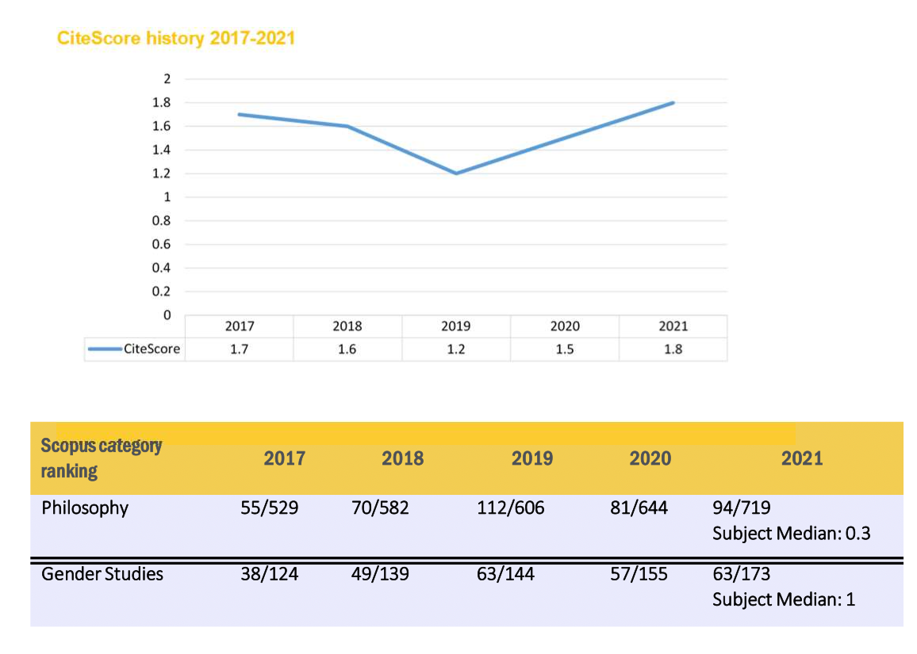

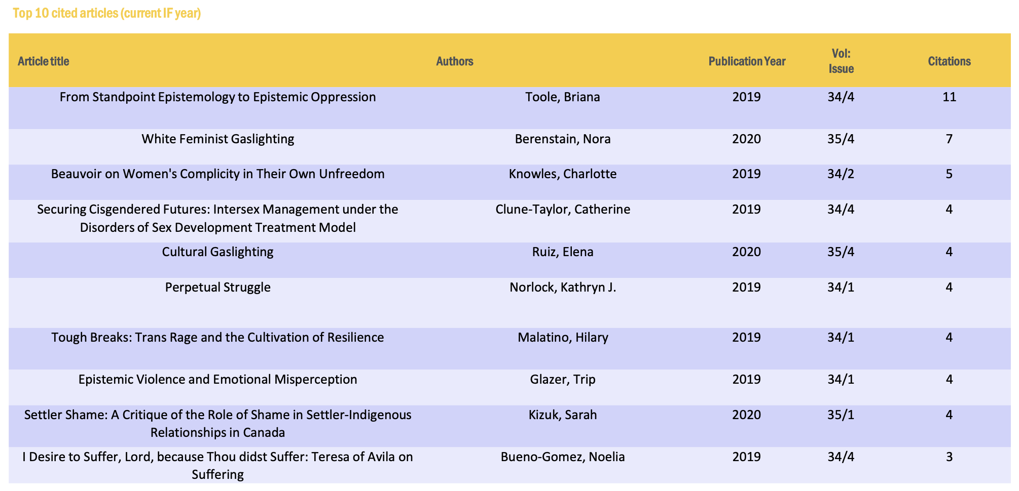

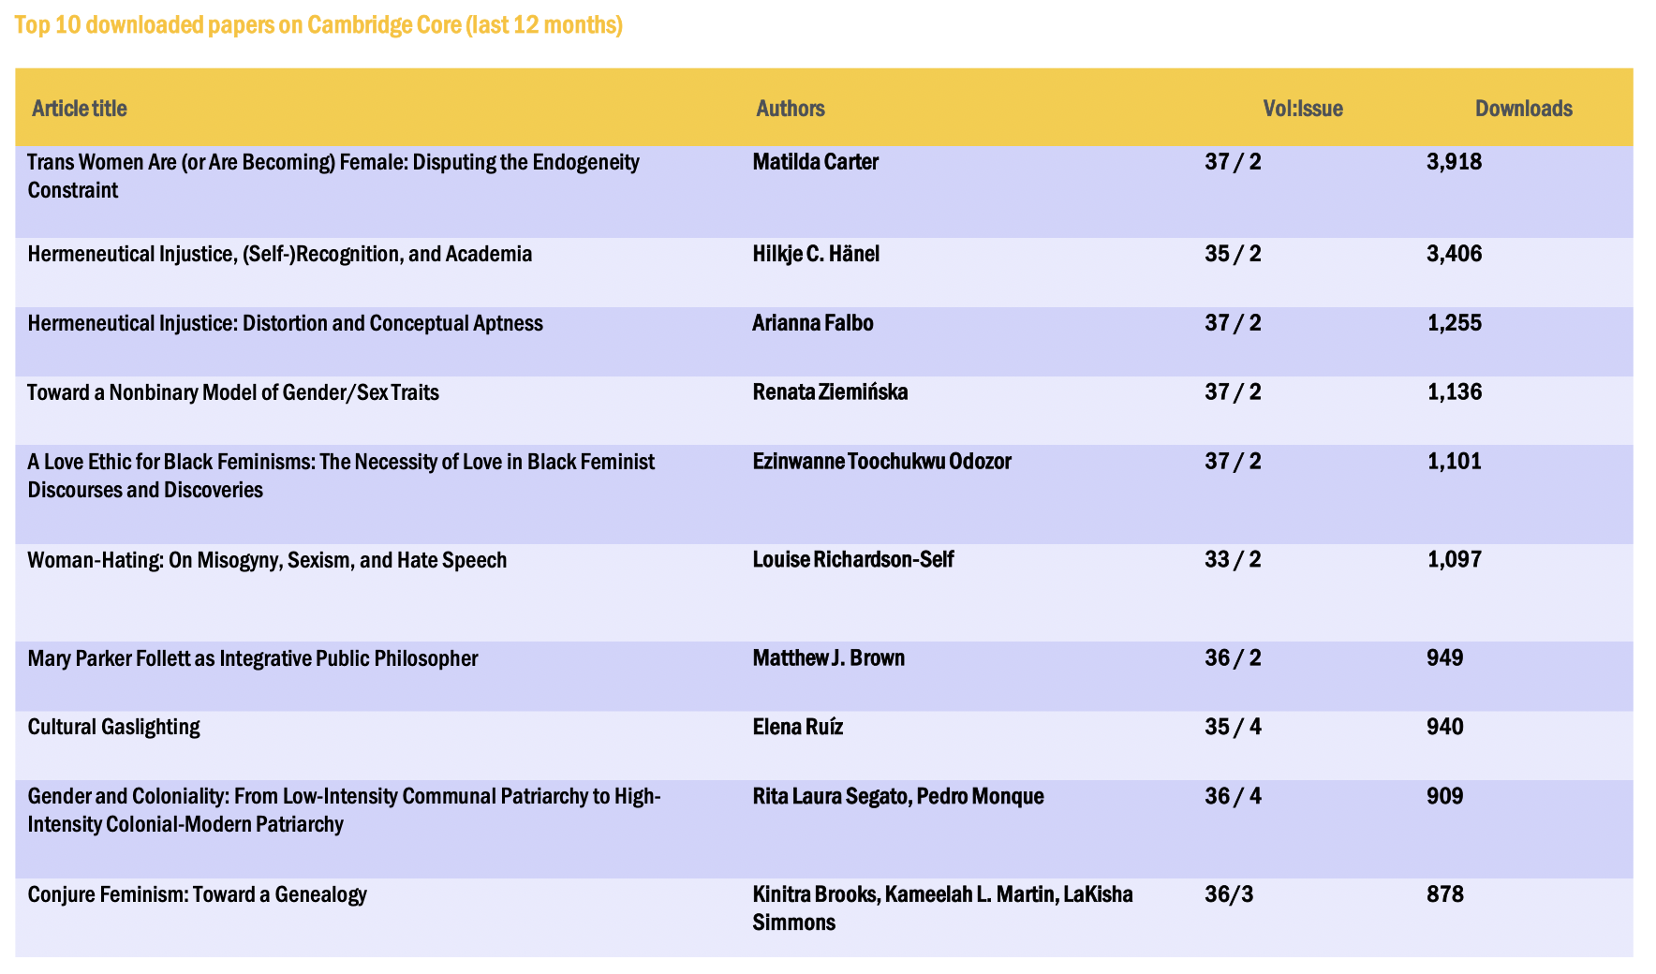

PUBLISHER RELATIONSHIP

The relationship between the Co-editors, Managing Editors and Cambridge University Press continues to be smooth and productive. CUP is keen on working on Hypatia’s marketing strategies and transition to Open Access publishing. CUP is working implementing demographic tracking for authors and reviewers via ScholarOne, a feature that the Team has requested and will be happy to use toward our aims of greater diversity. CUP will take over the copyediting of book reviews soon.

2022 REVENUES AND ROYALTY PAYMENT

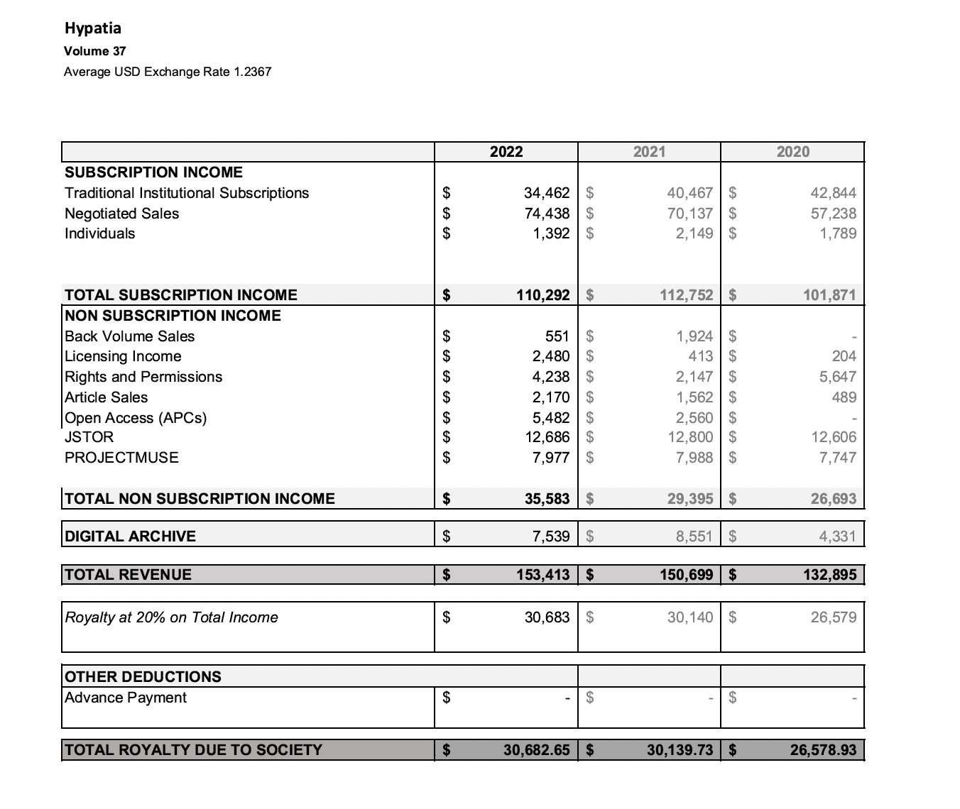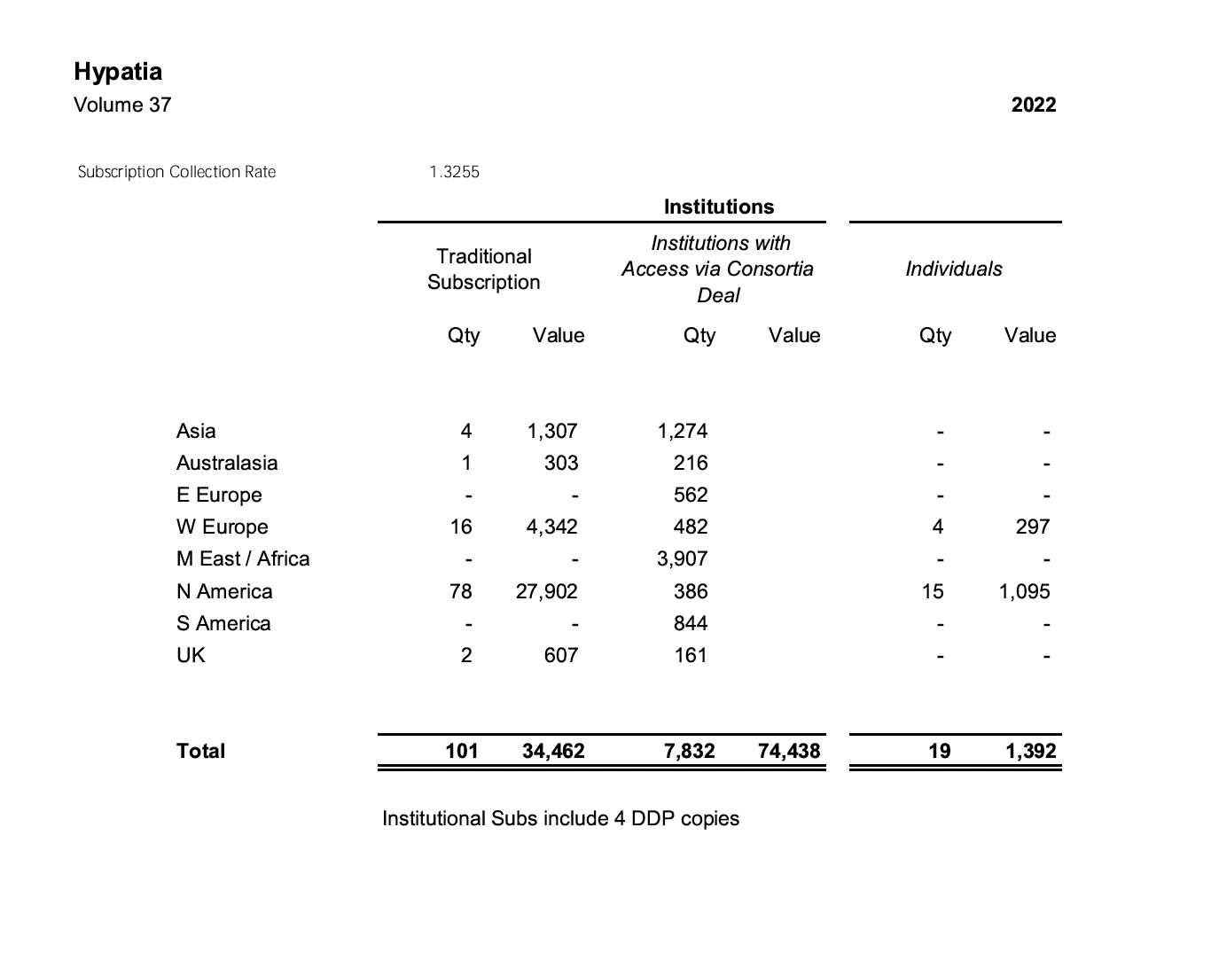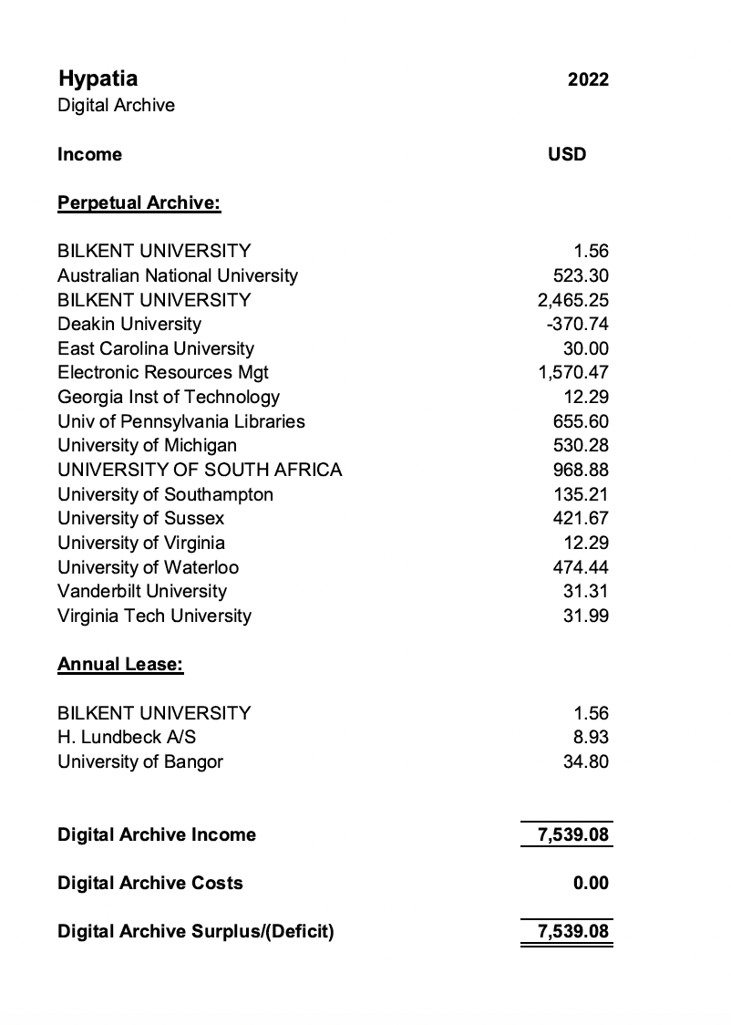

In May, 2023, Sally Hoffman sent the accounting, above. She also made requests as follows, that were recently forwarded to the treasurer(s) (outgoing and incoming) of the NPB:

* If you are happy with the account as it stands, I would be grateful if you could send me an invoice for the amount now owing.

* With regard to pricing for 2024, we are recommending an inflationary increase of 6% to online only rates modified by a discount that takes into account the increasing volume of open access material published in the journal. For Hypatia, this results in a decrease of 4.6%. Are you happy for us to proceed on this basis?

* We would like to recommend discontinuing print. There are only a tiny number of subscribers taking this option now, and it is neither commercially viable for us to continue, nor is it in line with our commitment to reducing the carbon imprint of the Press. Please let me know if you have questions or concerns about this. Over half of our journals will be online only in 2024 (including Canadian Journal of Philosophy and Journal of the American Philosophical Association).

ISSUES SPECIFIC TO 2022
Cup will Assume HRO Copyediting
CUP will soon take over the copyediting of book reviews for HRO.

Search for New Editorial Team
The Associate Editors, per Hypatia’s Governing Document, formed and chaired a Search Committee for a new editorial team. María del Rosario Acosta chaired the committee and reports that the AE Board as a whole served as the committee. Ann Garry served as Non-Profit Board Representative. An open call for the new team was drafted and circulated widely in October 2021 (on the Hypatia website and other databases). The AEs are currently waiting for the recommended team's final proposal, after a process of inquiries and vetting. The AE’s chosen team will go to the NPB for ratification. Throughout the year, the Editorial Team offered the Associate Editors support. Editors and Managing Editors answered questions and queries from and held several meetings with interested parties.

María del Rosario Acosta-López (Chair of Search Committee), reports as follows (edited for brevity and clarity by Bonnie Mann and Rocio Zambrana): We opened the call for an editorial team in October 2021. It was placed at the website (http://hypatiaphilosophy.org/profession/call-for-nominations-and-proposals-new-editorial-team-for-hypatia/) and circulated widely among databases. The AE agreed that we would all serve as the official search committee, with me as chair and Ann Garry as external member of the committee. The team that was ultimately recommended to the NPB for approval (the NPB must approve their final budget) submitted a statement of interest that was vetted and revised by the Associate Editors as a whole. Final budgetary approval needs to be ratified by the NPB after looking at the final document that includes institutional support letters of commitments from their universities and detailed budget proposals (and this is also the reason why we have not made a formal announcement yet). The new team is in the process of getting that ready (they are in a good position because two institutions want to host the journal and thus are competing for better conditions for the team), and they have told us we'll hear from them soon. Once the NPB approves the budget, the AEs will take a final vote on the appointment of the new team and make a formal announcement.

The current editorial team was essential in the process, because they offered to answer questions and inquiries from interested parties, and held a number of meetings during the search period. The AE is very thankful for this effort and extra work on your part. Nancy Tuana, NPB Treasurer, and Hypatia’s MEs also played key roles in consulting with potential editors.

ACCOMPLISHMENTS

Hypatia Archive

The gift agreement donating the Hypatia archives at the University of Oregon Library’s Special Collections and University Archives has been completed. Physically, that gift included the full run of the journal and some promotional materials from previous editorships. Digitally, the gift includes the extensive collection of archival videos that used to be hosted on the Hypatia website, but can no longer be. UO Special Collections has promised to catalog and upload these materials and we expect those tasks to be completed in time for the ceremonial opening of the archives during the 40th anniversary conference in September 2023. The plenary panels from the 40th anniversary conference will also be recorded and become part of the digital archive.

At this time, Southern Illinois University, Edwardsville, continues to house the earlier Hypatia archive. We hope to consolidate both archives at Oregon or to replicate materials at Edwardsville for inclusion in the Oregon collection in the future. We will also, on the occasion of the 40th anniversary conference, solicit any donations of early correspondence around the journal’s founding still held by the women involved in that correspondence.

Hypatia’s 40th Anniversary Conference
Planning for Hypatia’s 40th Anniversary Conference, “Hypatia’s Promise: Opening the Archives, Charting Feminist Futures,” has been underway all year. https://center.uoregon.edu/Hypatia/2023/
The official launching of the Oregon Hypatia Archives will take place at this event. The ET opted for a series of 5 invited panels rather than keynote speakers. https://center.uoregon.edu/Hypatia/2023/program/panelists.php
This allows us to shape the conference around key areas of feminist philosophical thought that have not always been well-represented in Hypatia, emphasizing “Feminist Futures,” while also giving some space to looking backward at Hypatia’s “archives”. Panels Include: “Looking Backward”, an invited panel of former Hypatia editors which will accompany the opening of the archives; “Trans Feminism”; “Woman, Life, Freedom: Iranian Women’s Uprising”; “Decolonial Feminism in Latin Amefrica”; “Mapping History, Engaging with Possibility: Black Feminism(s) Today”; “Reproductive Justice and Feminist Liberatory Politics”.

While the Editorial Team originally sought to recruit members of the Board of Associate Editors and the Non-profit Board to join us in this work, it seems those two bodies were too burdened by other tasks, including recruiting a new editorial team, to participate in the various organizing committees. The Editorial Team proceeded to form 3 separate organizing committees, each chaired by a member of the ET. Erin McKenna chairs the Budget Committee, Camisha Russell chairs the Logistics Committee, and Bonnie Mann chairs the Program Committee. The Managing Editors have contributed to these efforts as well. Sarah LaChance Adams has participated on the Program Committee and Caroline Lundquist has participated on the Budget and Logistics Committees. Other committee members are graduate student volunteers from the University of Oregon, and the ET is exceedingly grateful for their enthusiasm, commitment and organizing skills. Graduate volunteer members are as follows:

Budget Committee chaired by Erin McKenna: Nick Denning , Gonzalo Bustamante Moya, Kirstin Waldkoenig

Logistics Committee chaired by Camisha Russell: Annie Ring, Brooke Burns, Tali Bitton

Program Committee chaired by Bonnie Mann: Maia Wellborn, Rhiannon Lindgren, Julie Williams-Reyes, Amanda Dubrule, with Zeinab Nobowati helping in the initial stages.

As of this writing (6/19/2022) all three committees are far into their organizing work.

Budget: We have a developed budget with grants and donations from the Hypatia Non-profit Board, the Oregon Humanities Center, UO Center for the Study of Women in Society, UO Libraries and Special Collections, UO College of Arts and Sciences, UO Philosophy, UO Women’s, Gender, and Sexuality Studies, UO English, UO Anthropology, UO Political Science, Emory University, and $20,000 allocated from the Hypatia budget for the conference.

Logistics: We have a well-developed and functioning web page, which includes online registration, a searchable program, and is linked to a database that allows the management of papers and participants. We have worked with on-campus partners to secure meeting space, on-campus housing, and catering. We also have conference rates with two conveniently located hotels. We have partnered with Special Collections to plan an extensive reception celebrating the opening of the archives and are creating posters to display in the reception venue to showcase the history of Hypatia. We have also done a walkthrough of the main conference site to identify places for registration, coffee breaks, and signage. We also maintain a conference-specific email account to address all questions from conference goers and presenters.

Program: The Program Committee worked with the ET to select topics for invited panels, created a list of possible invitees, worked with the ET to finalize and prioritize this list, invited the panelists, and managed the process of securing commitments from the panelists. There are 19 invited panelists. (The program committee has managed the invitation process for 15 of these, while Rocio Zambrana has managed the entire planning process for the “Amefrica Latina” panel). The committee created a call for papers, advertised the conference, created a review process in conversation with the ET, reviewed all submissions, and recently accepted 76 papers, including papers submitted as part of panels. The committee has organized and scheduled the accepted papers and is currently working to finalize the schedule given changes requested by various presenters. The committee has also played an active role in creating a conference poster and public-facing information about invited panels and the conference as a whole.

Keywords Project
The transition has been made in ScholarOne from a system that allows anyone asked to enter keywords to enter terms of their own choosing to a system that offers drop-down menus of standardized keywords from which to select. People can choose from both the standardized Keywords menu and a Key Figures menu. They can also suggest their own additional terms in the case that the topic or figure is not available in the two menus.

While that was a crucial first step, it has not yet made referee searching easier for the editors since only a small percentage of referees in the database are using the updated system. At this time, anyone who signs into ScholarOne will be prompted to update their keywords to the new format if they have not already done so. Our aim is to have a mass email sent prompting those who have not signed in recently to update their keywords, but we have not been able to have this done because the CUP ScholarOne team experienced almost a full staff turnover. Hopefully we can get that done this year, but it will still probably be some time before a majority of referees are using the new keywords system.

Revision of Managing Editor Manual
Sarah LaChance Adams has been working to very substantially revise the ME manual that this team inherited from the previous one. This was necessitated in part by Hypatia’s new partnership with Cambridge University Press, but was also motivated by the need to have a more helpful manual prepared for the incoming team. An enormous amount of work (50-80 hours) has gone into this important task. Sarah was assisted by her undergraduate intern at the University of Florida, Madeline Catton.

